

PE-xxxx  
Revision B

WS1050 MEMS CYCLING AND HOLD DOWN

TEST PROCEDURE

Table of Contents

1. Purpose and Scope 3

1.1 Purpose 3

1.2 Scope 3

2. Responsibilities 3

3. REFERENCE DOCUMENTS 3

4. FORMS 3

5. DEFINITIONS (Not Applicable) 3

6. EQUIPMENT AND MATERIALS 4

7. REQUIREMENTS AND PROCEDURES 4

7.1 Basic Hardware, Software, and Environmental Requirements 4

7.1.1 Cycling and Hold down Hardware 4

7.1.2 Cycling and Hold down Software 6

7.1.3 Cycling and Hold down environmental controls 6

7.1.3.1 Provide controls temperature and humidity 6

7.1.3.2 Meet calibration requirements defined in PE-0002 7

7.2 MEMS Switch Cycling Stress 8

7.3 MEMS continuous Hold Down stress 8

7.4 Reject Criteria 8

7.5 General Set-up and Handling Guidelines 8

7.6 Test Set-up Procedure 9

7.7 Test Operating Procedure 11

8. REVISION HISTORY 17

# Purpose and Scope

## Purpose

This document defines the procedures and requirements for cycling and holding down stresses for MEMS tunable capacitors.

## Scope

This procedure applies to the qualification and ongoing production monitoring of WS1050.

# Responsibilities

The Product Engineering function is responsible for assuring compliance to the requirements of this document.

# REFERENCE DOCUMENTS

|  |  |
| --- | --- |
| Document No. | Document Name |
| PE-0002 | Equipment Calibration Procedure |

Table 1 Reference Document List

# FORMS

|  |  |
| --- | --- |
| Form No. | Form Name |
|  |  |

Table 2 Form List

# DEFINITIONS (Not Applicable)

# EQUIPMENT AND MATERIALS

Equipment consists of:

|  |  |  |  |
| --- | --- | --- | --- |
| **Item** | **Model** | **Manufacturer** | **Comments** |
| Computer (equipment controller) | PC with Window XP, 7 | Any |  |
| Software (equipment controller) | LabView 2012 or Higher |  |  |
| GPIB-USB-HS | 778927-01 | National Instruments |  |
| Triple Output Power Supply | E3631A | Agilent/Keysight | w/ GBIP interface |
| Source Meter | 2400 | Keithley | w/ GBIP interface |
| DMM | 2000 | Keithley | w/GPIB interface |
| FPGA | PIX-7813R | National Instruments |  |
| PXI Card Chassis | PIX-1033 | National Instruments |  |
| DUT boards | Various**1** | --- | WiSpry Design |
| SHC68-68-RDIO Shielded Cable | 191667-01 | National Instruments | NI Cables |

Table 3 MEMS Reliability Stress Stand Equipment List

Notes:

**1** WS1050 board is 36 positions (model WS-EVB-165)

# REQUIREMENTS AND PROCEDURES

## Basic Hardware, Software, and Environmental Requirements

* + 1. Cycling and hold down hardware (boards, cables, connectors, bench equipment) must be able to:
       1. Meet the electrical conditions specified in sections 7.2 and 7.3.
       2. Meet WiSpry calibration requirements specified in PE-0002.
       3. Be sufficiently robust to ensure minimum leakage currents.

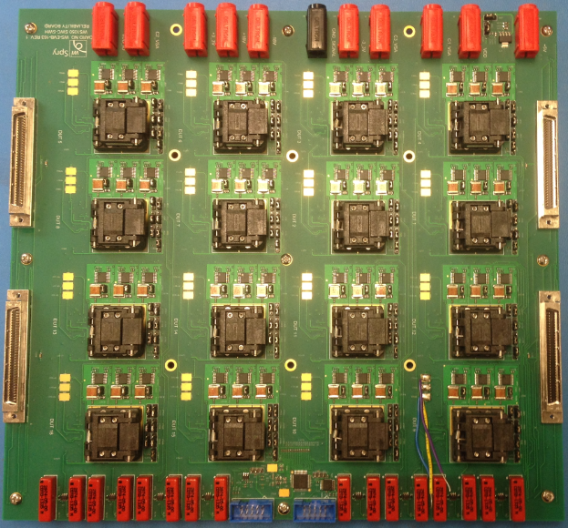

Picture 1 16 DUT Board

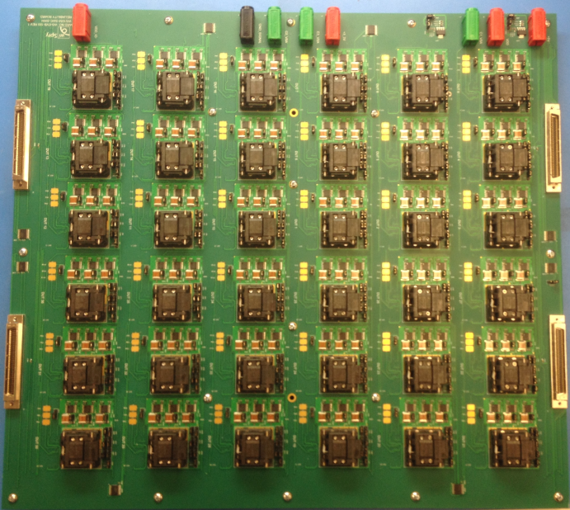

Picture 2 36 DUT Board

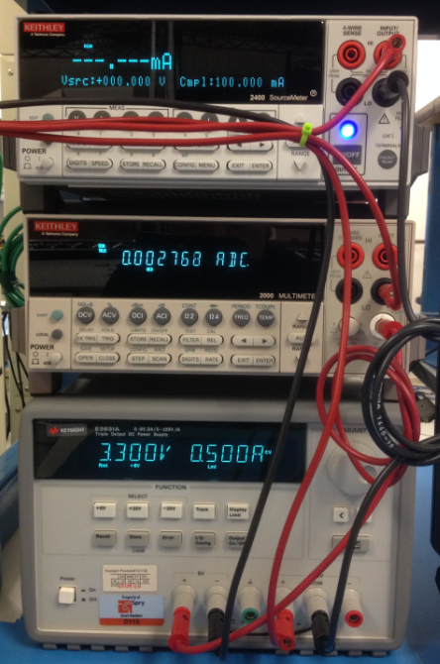

Picture 3 Test Equipment

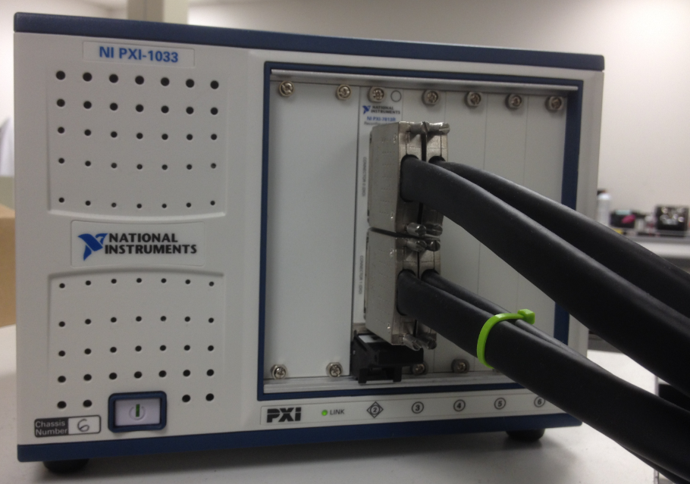

Picture 4 Chassis and NI Cables

* + 1. Cycling and hold down software should:
       1. Allow for insitu monitoring for stiction events.
       2. Meet the electrical conditions specified in sections 7.2 and 7.3.
    2. Cycling and hold down environmental controls shall:
       1. Provide control of temperature and humidity.

7.1.3.1.1 The ESPEC where we can control the temperature and humidity

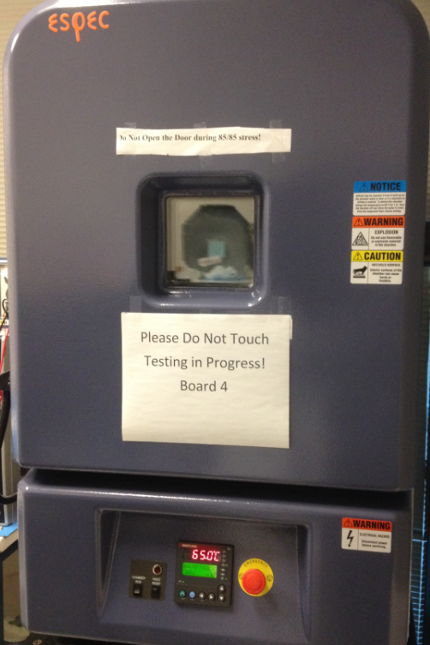

Picture 5 the ESPEC Oven Controls Temperature and Humidity

* + - * 1. Yamato ovens where we control temperature, not humidity. But lab humidity is monitored by using OMEGA model CTH89

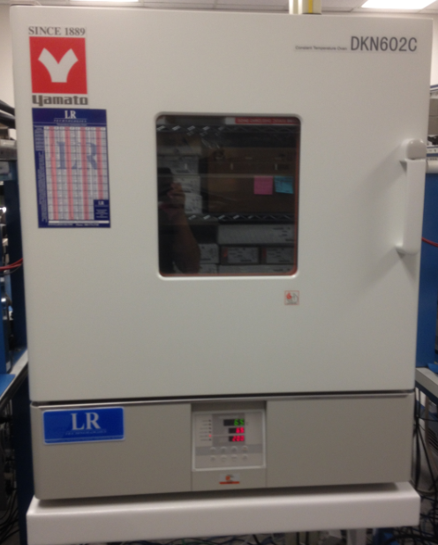

Picture 6 the Yamato Oven Controls Temperature

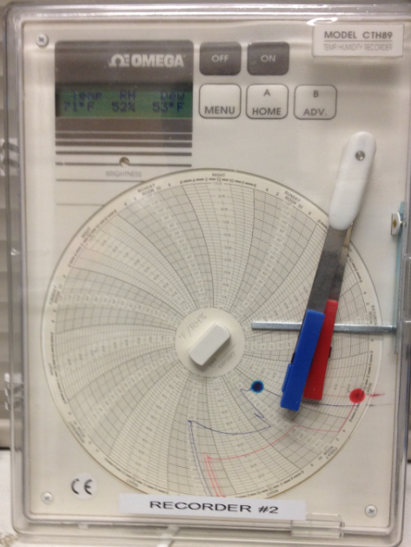

Picture 7 the OMEGA Monitors the Lab Humidity

* + - 1. Meet calibration requirements defined in PE-0002.

## MEMS Switch Cycling Stress

The cycling conditions for product qualification and ongoing monitoring are:

|  |  |
| --- | --- |
| **Stress Condition** | **Requirement** |
| MEMS Operating Voltage (VOP) | 44 V |
| VDD | 3.7 V @ 12 KHz |
| Temperature | 65 oC |
| Frequency | 12 KHz |
| Duty Cycle | 25% |
| Dual Voltage Actuation (DVA) | OFF |
| Beam Actuation | All beams cycles simultaneously |
| Beam Read Points | 0, 2K, 10K, 100K, 1M, 5M, 10M, 20M, 30M … TTF |
| Test Sequence | In series: Bank 1, Bank 2, then Bank 3 |

Table 4 MEMS Switch Cycling Stress Conditions for Product Qualification

## MEMS Continuous Hold Down Stress

The continuous hold down conditions for product qualification and ongoing monitoring are:

|  |  |
| --- | --- |
| **Stress Condition** | **Requirement** |
| MEMS Operating Voltage (VOP) | 44 V |
| VDD | 3.3 V |
| Temperature | 65 oC |
| Frequency | ---- |
| Duty Cycle | 100% |
| Dual Voltage Actuation (DVA) | OFF |
| Beam Actuation | All beams cycles simultaneously and held for the stress duration |
| Beam Read Points | 0, 5m, 10m, 15m, 30m, 45m, 60m, 90m … 5h, 6h, 7h … TTF |
| Test Sequence | In series: Bank 1, Bank 2, then Bank 3 |

Table MEMS Continuous Hold down Stress Conditions for Product Qualification

## Reject Criteria

For both cycling and hold down, the following conditions define a reject reading:

COFF +/- 10% of the series Cmin of 460fF

CON +/- 10% of the series Cmax of 6.57pF

## General Set-up and Handling Guidelines

### Handling recommendations for ESD

* + - 1. Stabilize oven temperature prior to loading parts, 15 minutes minimum
      2. Preconditioning of new stress boards (to remove excess absorbed moisture), 24 hour bake at 85C
      3. Socket inspection after each run and cleaning/repair as required

## Test Set-up Procedure

* + 1. Figure 1 shows the test set-up block diagram for WS1050 Reliability Test, Multi DUT.
       1. Using banana plug cables to connect all test equipments as in Figure 1.
       2. For power supply E3631A, use channel 1 for VDD, channel 2 for +3.3V.



Figure 1 MEMS Cycling and Hold down Reliability Stress Test Set-Up Block Diagram

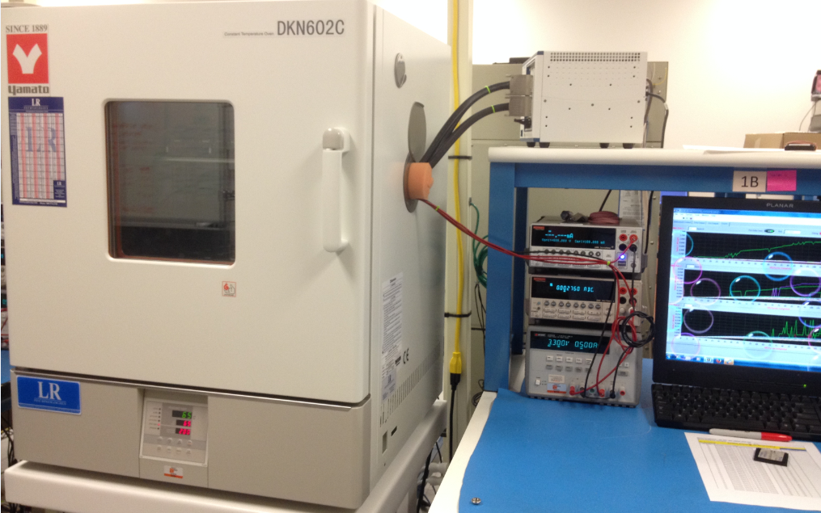

Picture 8 MEMS Cycling and Hold down Reliability Stress Test Set-Up

* + 1. Figure 2 shows the front panel of the test program (for the WS1050 version 1.5)
    2. Contact WiSpry Engineering for the latest version of the test program.
    3. Test programs are located in directory: S:\Software_Control\Released\36 DUT Board

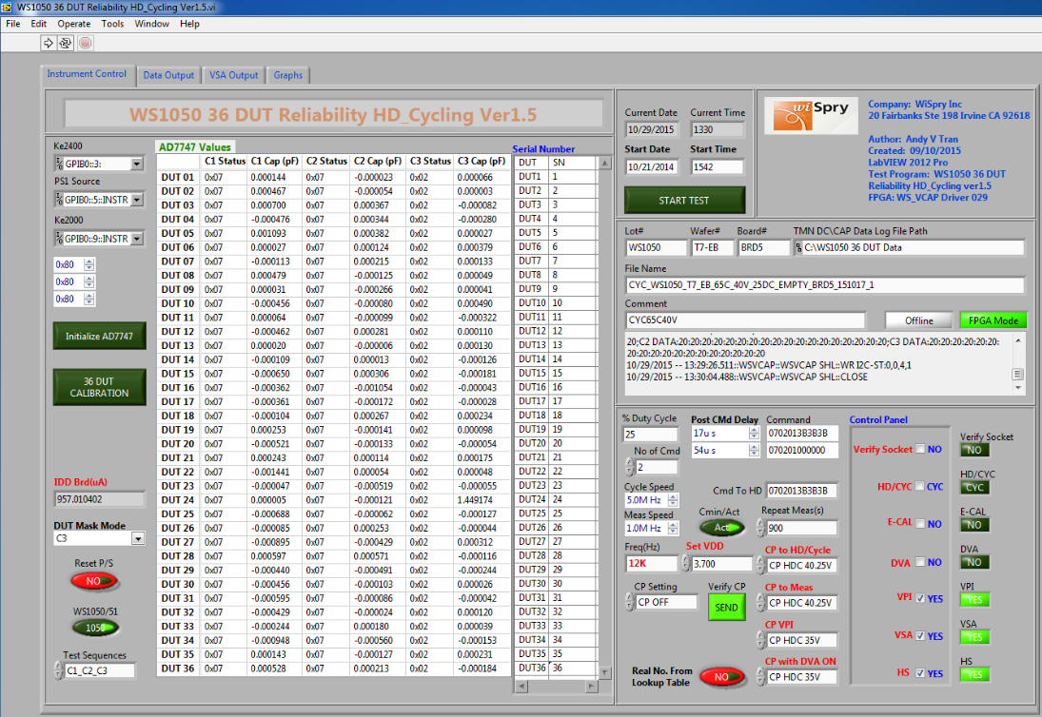

Figure 2 Front Panel of the WS1050 36 DUT Stress Test Program

## Test Operating Procedure

* + 1. Set temperature to meet requirement (25C, 45C, 65C)
    2. Set-up test program
* From labVIEW test program (Figure 2) click  this button at the top left corner to run the test program, it will pop-up a dialog box (Figure 3) below to ask the look up table for read point

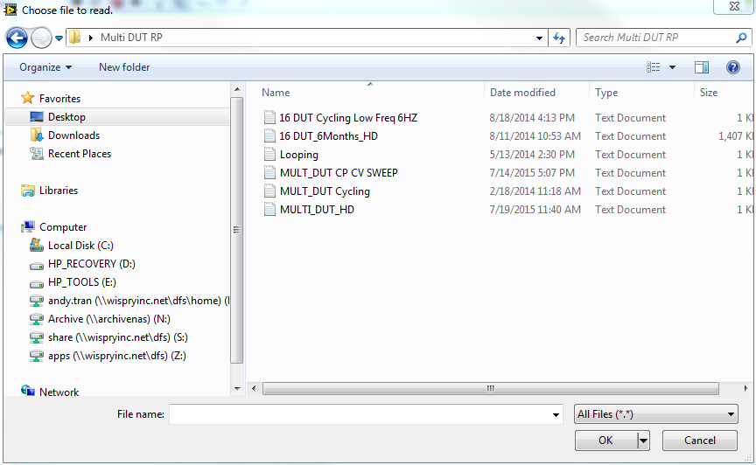

Figure 3 Share Drive Folder for Multi-DUT Cycling or HD Read Point Definition

* Select the correct Read Point file depending on the stress being run;
  + Select **MULT_DUT Cycling** for cycling test
  + Select **MULT_DUT HD** for hold down test
* For calibration (Figure 4): All sockets should be empty and the capacitance values of 36 DUT should be around zeros “~0”for all three banks. If not, click on “36 DUT CALIBRATION” button to zero out the sockets

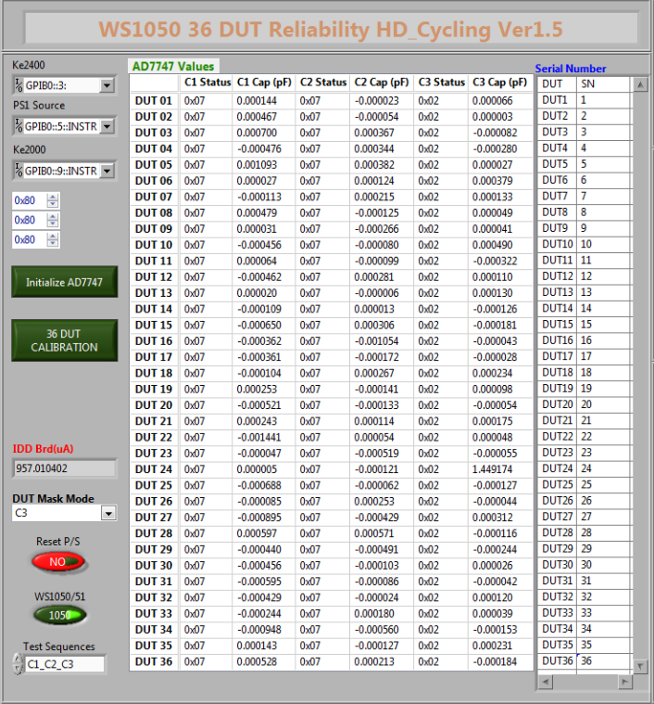

Figure 4 Empty Socket Calibration Summary Window

Note: If sockets are not zeros “~0”, click on “Initialize AD7747” button  to initialize the ADI chip, make sure the capacitance values will be less than 1pF (<1pF) for all three banks of 36 DUT, click on “36 DUT CALIBRATION” button to zero out the sockets.

* Set-up test condition (Fig. 5): The front panel below was set by default with cycling, DVA OFF, E-CAL OFF, VPI ON, VSA ON, HS (hand shake check) = ON, VDD = 3.7V, cycle speed = 12 KHz, CP stress = 40.25V, CP VPI = 35V.

# 

Figure 5 Test Condition Set-Up Front Panel for default cycling conditions (DVA = OFF, ECAL = OFF, VPI = ON, HS (Handshake) = ON, Duty Cycle = 25%, VDD = 3.7V, Frequency = 12 KHz, Charge Pump = 40.25V, Charge Pump VPI = 35V

* Verify Socket: This run is required for the first set up (new board) to make sure the board is stable before stressing devices
* HD/CYC: This will be selected/unselected to run Hold down Stress/Cycling Stress
* E-CAL: This will be selected/unselected to run stress with E-CAL ON/OFF
* DVA: This will be selected/unselected to run stress with Dual Voltage Actuation ON/OFF
* VPI: This will verify the Voltage Pull-In for each bank
* VSA: This is a Voltage Self Actuation Test by bank
* HS: Handshake check is a continuity test to verify the contact
* Set-up with standard stress (cycle): All Drivers ON, All Drivers OFF, 25% Duty. All numbers should be set as same as the boxes are shown below**:**

# 

Figure 6 All Drivers ON and All Drivers OFF Set Up Box for 25% Duty Cycle. The numbers in the command box should be represented as shown

* Set-up with special stress (cycle): C1 ON, C2 OFF, C3 OFF; C1 OFF, C2 ON, C3 OFF; C1 OFF, C2 OFF, C3 ON, 33% Duty. Make sure all the numbers will be set as same as the boxes are shown below:

# 

Figure 7 Special Cycling Stress Test Set-Up with 33% duty cycle. Note: Commands numbers must be as shown in the Figure

* Set-up for stress (Hold Down): All Drivers should be closed during hold down, 100% duty, this was set by default



Figure 8 Stress Test Control Set Up for Conditions Hold Down. Note: Commands numbers must be as shown in the Figure

* Figure 9 shows the front panel is set-up to collect the test data.

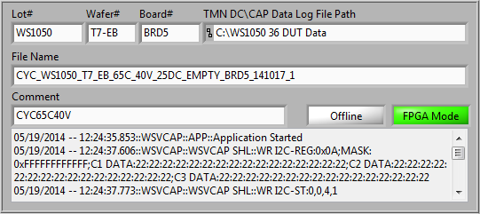

Figure 9 Front Panel to Set Up Data Collection

Note: The file name format will be:

**stress_lot#_wafer#_design_temperature_CPV Stress_duty_brd#_yymmdd_run**

* The test can be set to start immediately by clicking on the START TEST button; alternatively the start date and time can be programmed as shown in Figure 10.

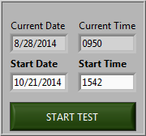

Figure 10 Cycling or Hold down Stress Initiation for immediate or delayed start

**Note:** **The time shall be set at least 30 minutes to wait after loading parts to the board in the oven/chamber. This time is required for the stabilization of the board dwell time at the temperature before to run stress.**

* The front panel (Figure 11) displays the capacitance values for every read point.

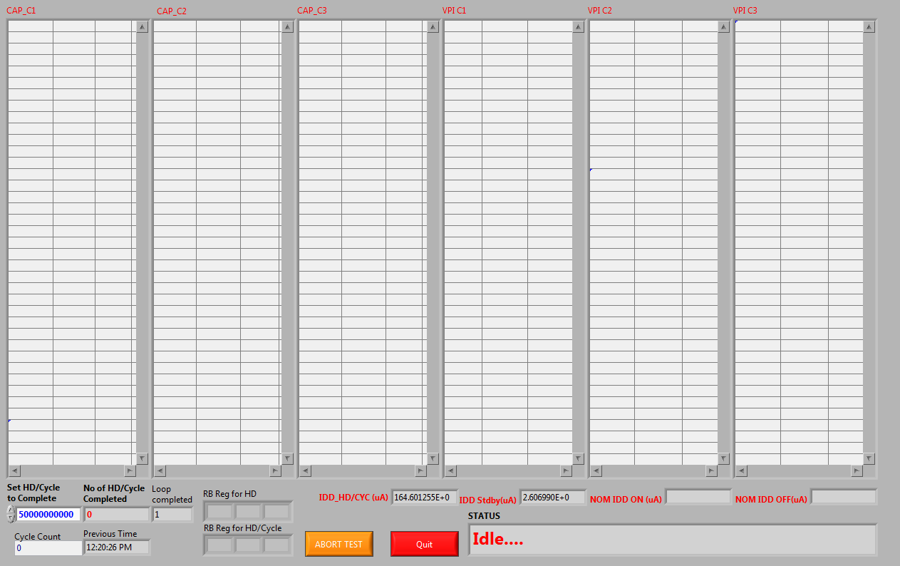

Figure 11 This Front Panel will display the capacitance values at every read point

* The front panel (Figure 12) displays VSA, HS check, EFUSE, % Delta CAP for every read point

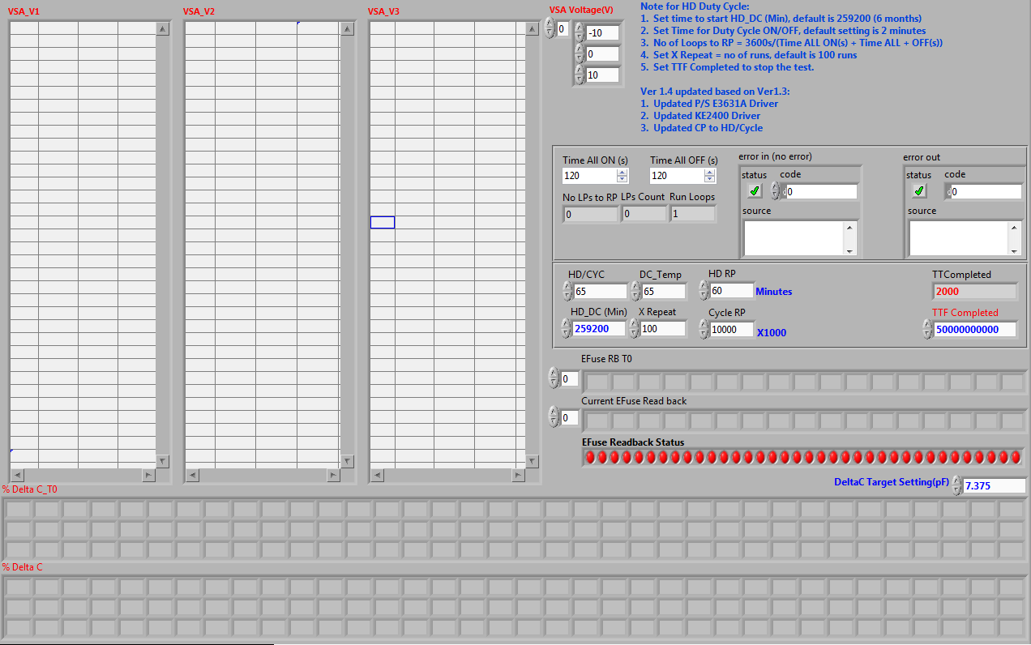

Figure 12 the Front Panel shown will display the VSA, HS check, EFUSE, %Delta CAP for every read point

* Figure 13 shows the output results, so that changes in CMIN can be monitored during stress.

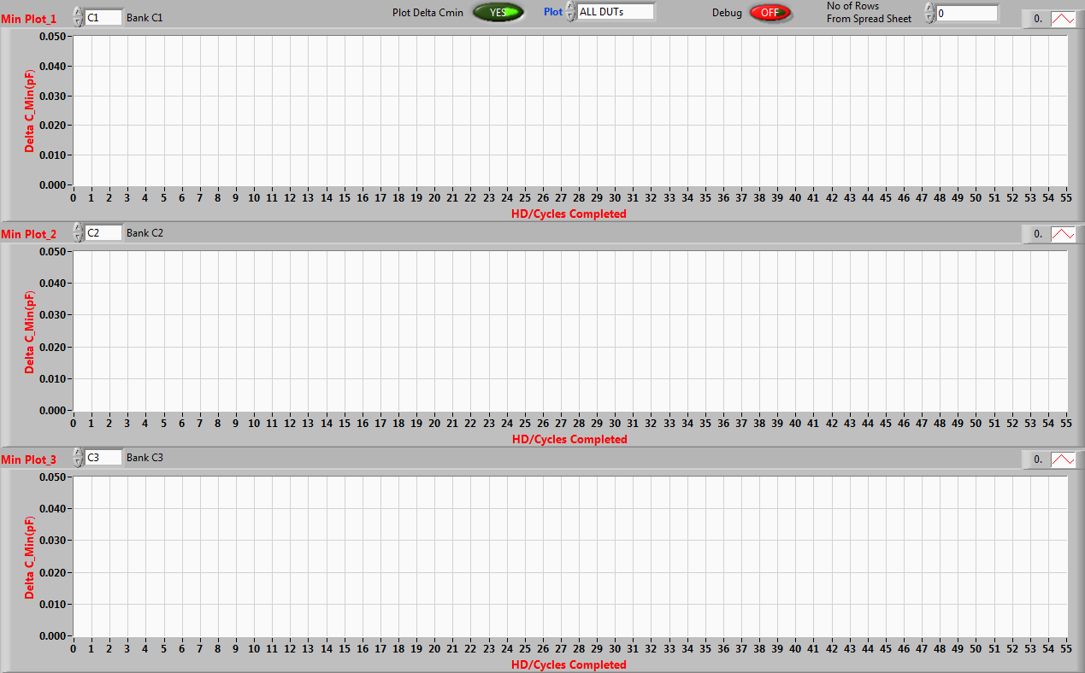

Figure 13 This shows the Output results for monitoring the instantaneous changes in CMin

* Stop stress or abort the test: The test can be aborted immediately by click on the ABORT TEST button (Figure 14) or enter the number that will be set to complete the test (5 billion cycles was set by default).

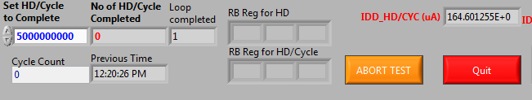

Figure 14 This Front Panel can be used to ABORT the stress or to set the minimum number of cycles to achieve. The button ABORT TEST will abort the stress

* This is a special test for Hold down during cycle test.
* The standard Hold down depends on the number set up from the box “HD_DC (min)”, (259200 min = 6 months is set by default).
* When the number from “Set HD/Cycle to Completed” = “HD_DC (min)” then the next run will be two minutes ON (turn All Drivers ON), two minutes OFF (turn All Drivers OFF)

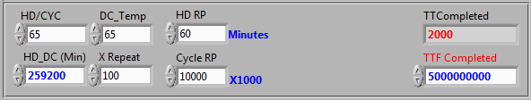

Figure 15 This Front Panel can be used for Hold down during cycle test.

# REVISION HISTORY

|  |  |  |  |
| --- | --- | --- | --- |
| Rev | Description | Editor | Date |
| A | Initial Release | M. Johnson | 12-Aug 2015 |
| B | Modify and Update | Andy V Tran | 29-Oct 2015 |